#include <iostream>

#include<queue>

using namespace std;

int main()

{

queue<int> myqueue;

myqueue.push(0);

myqueue.push(1);

myqueue.push(2);

while(!myqueue.empty())

{

cout<<' '<<myqueue.front();

myqueue.pop();

}

}

Output:

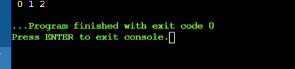

#include <iostream>

#include <queue>

using namespace std;

int main()

{

queue<int> myqueue;

myqueue.push(0);

myqueue.push(1);

myqueue.push(2);

myqueue.pop();

myqueue.pop();

while (!myqueue.empty())

{

cout<<' '<<myqueue.front();

myqueue.pop();

}

}

Output:

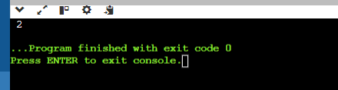

#include <bits/stdc++.h>

using namespace std;

void showstack(stack <int> s)

{

while(!s.empty()){

cout<<'\t'<<s.top();

s.pop();

}

cout << '\n';

}

int main()

{

stack <int> s;

s.push(10);

s.push(30);

s.push(20);

s.push(5);

s.push(1);

cout<<"The stack is : ";

showstack(s);

cout<<"\ns.size(): "<<s.size();

cout<<"\ns.top(): "<<s.top();

cout<<"\ns.pop(): ";

s.pop();

showstack(s);

return 0;

}

Output:

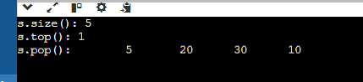

#include <iostream>

#include <list>

int main() {

// Create a list

std::list<int> myList;

// Insert elements at the end

myList.push_back(10);

myList.push_back(20);

myList.push_back(30);

// Insert elements at the front

myList.push_front(5);

myList.push_front(1);

// Display elements

std::cout << "List after push_back and push_front: ";

for (int val : myList) {

std::cout << val << " ";

}

std::cout << std::endl;

// Insert element at a specific position

auto it = myList.begin();

std::advance(it, 2);

myList.insert(it, 15);

std::cout << "List after insert: ";

for (int val : myList) {

std::cout << val << " ";

}

std::cout << std::endl;

// Erase element at a specific position

it = myList.begin();

std::advance(it, 3);

myList.erase(it);

std::cout << "List after erase: ";

for (int val : myList) {

std::cout << val << " ";

}

std::cout << std::endl;

// Remove elements by value

myList.remove(10);

std::cout << "List after remove: ";

for (int val : myList) {

std::cout << val << " ";

}

std::cout << std::endl;

// Remove elements based on a condition

myList.remove_if([](int n) { return n < 10; });

std::cout << "List after remove_if: ";

for (int val : myList) {

std::cout << val << " ";

}

std::cout << std::endl;

// Sorting the list

myList.sort();

std::cout << "List after sort: ";

for (int val : myList) {

std::cout << val << " ";

}

std::cout << std::endl;

// Reversing the list

myList.reverse();

std::cout << "List after reverse: ";

for (int val : myList) {

std::cout << val << " ";

}

std::cout << std::endl;

// Merging two lists

std::list<int> otherList = {40, 50, 60};

myList.merge(otherList);

std::cout << "List after merge: ";

for (int val : myList) {

std::cout << val << " ";

}

std::cout << std::endl;

// Clearing the list

myList.clear();

std::cout << "List after clear: ";

for (int val : myList) {

std::cout << val << " ";

}

std::cout << std::endl;

// Checking if the list is empty

if (myList.empty()) {

std::cout << "List is empty." << std::endl;

}

// Adding elements again

myList.push_back(100);

myList.push_back(200);

// Accessing front and back elements

std::cout << "Front element: " << myList.front() << std::endl;

std::cout << "Back element: " << myList.back() << std::endl;

return 0;

}

Output:

